Estat de l'art de llibreries Javascript i la seva funcionalitat.
Nom | Funcionalitat | Dependències | Foto de mostra | Web | Llicència
Prototype | Ajax + Tools |  | 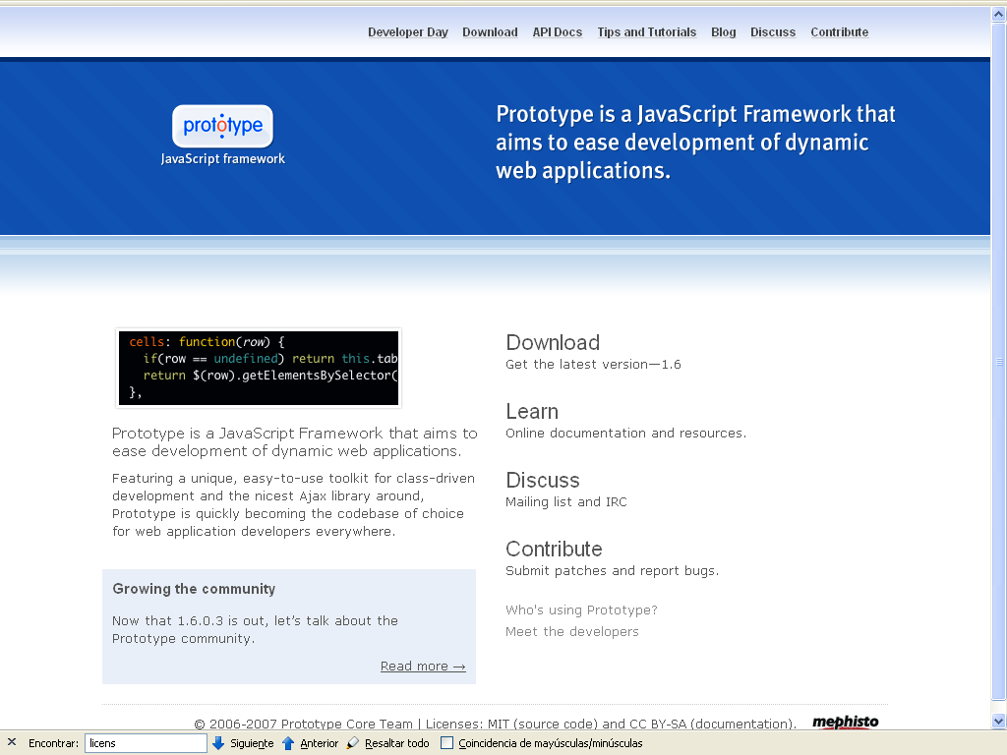 |  | MIT
Clean Ajax | Ajax senzill | Ajaxslt, openajax, pajhome | 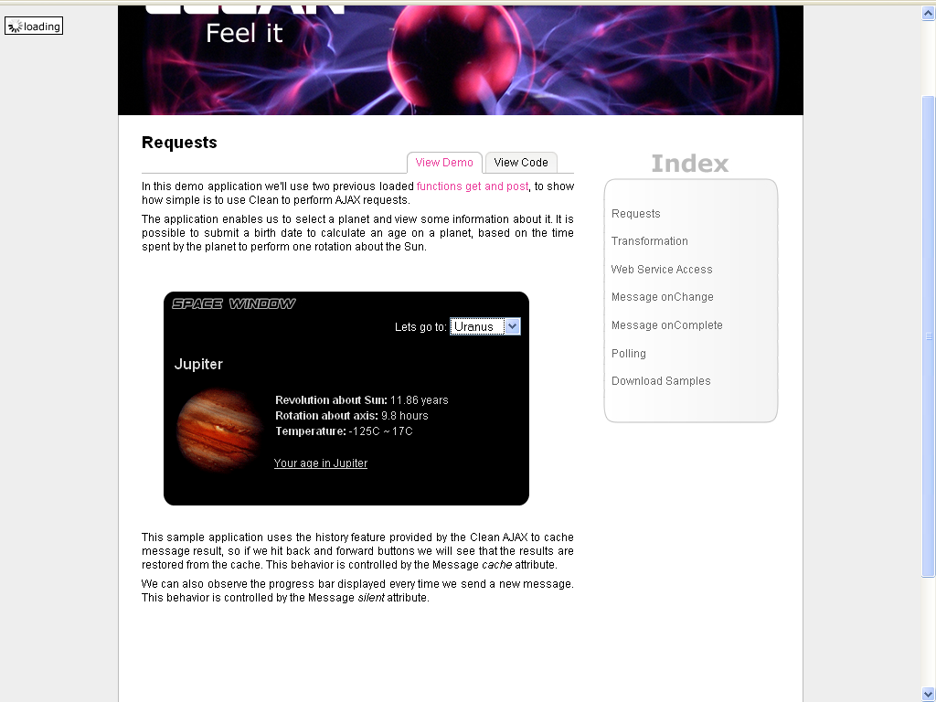 | http://clean-ajax.sourceforge.net/ | GPL
script.aculo.us | IGU + Ajax | prototype | 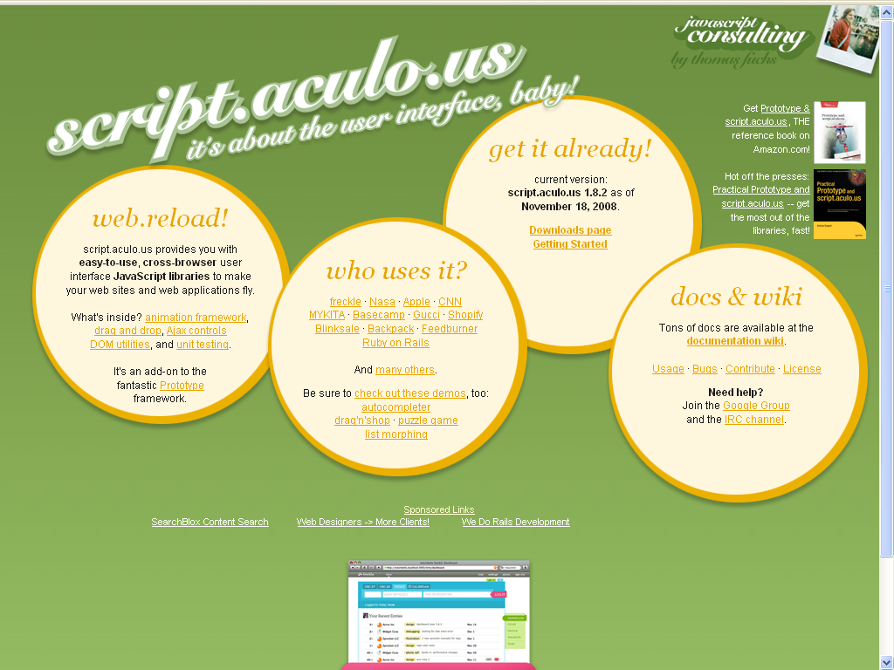 | http://script.aculo.us/ | Gpl like
mootools | Ajax + IGU |  | 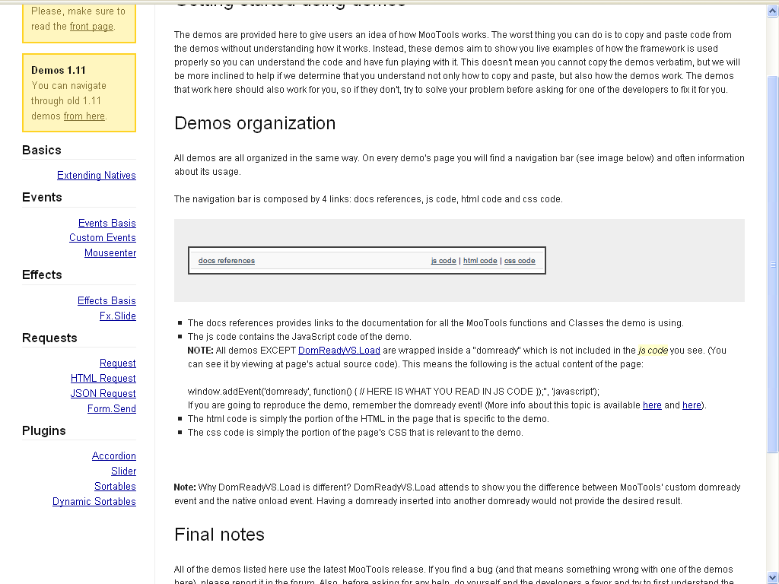 | http://mootools.net/ | MIT
MOOdalBox | Pop-Up's | mootools | 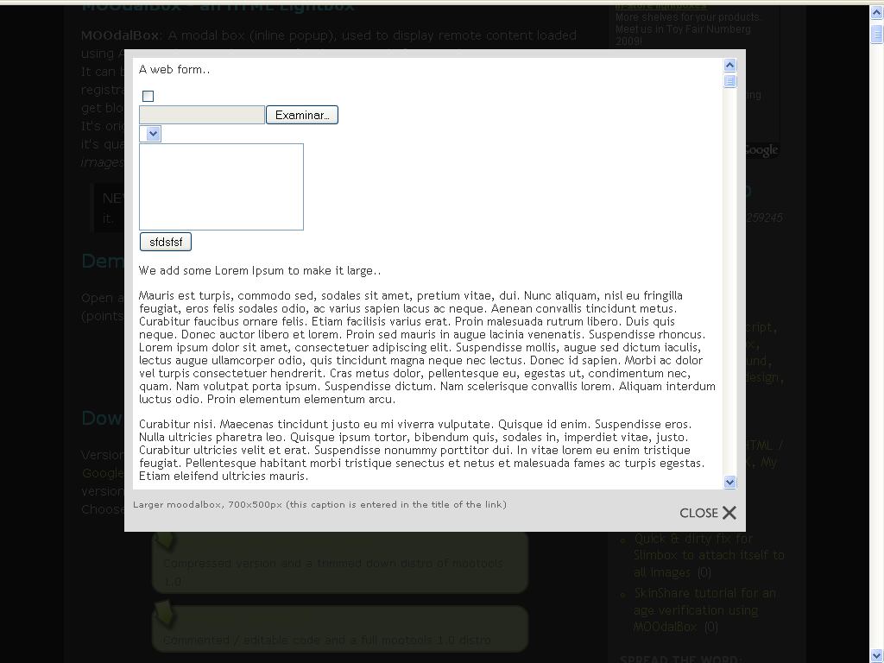 | http://www.e-magine.ro/web-dev-and-design/36/moodalbox/ | MIT
Slimbox | Photo viewer | mootools | 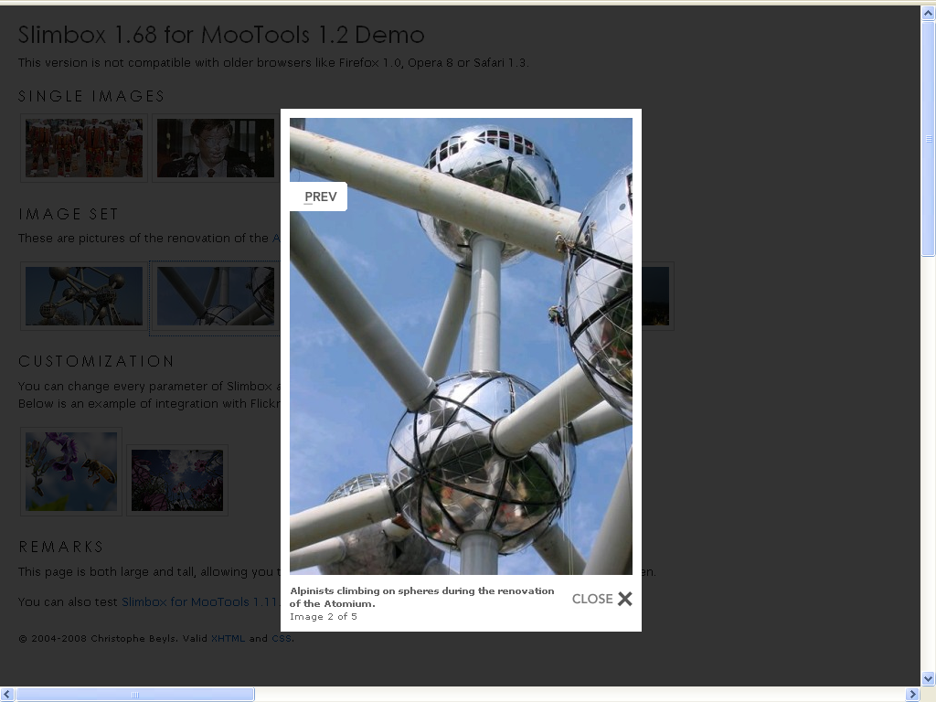 | http://www.digitalia.be/software/slimbox | MIT
Xfade | Fade multi-images banner js-efects |  | 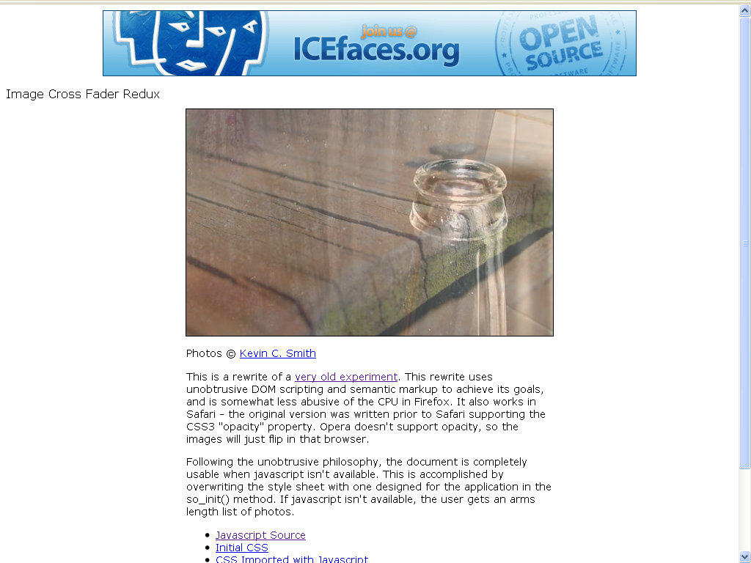 | http://slayeroffice.com/code/imageCrossFade/xfade2.html | ¿?
Slimbox 2 | Photo viewer | JQuery | 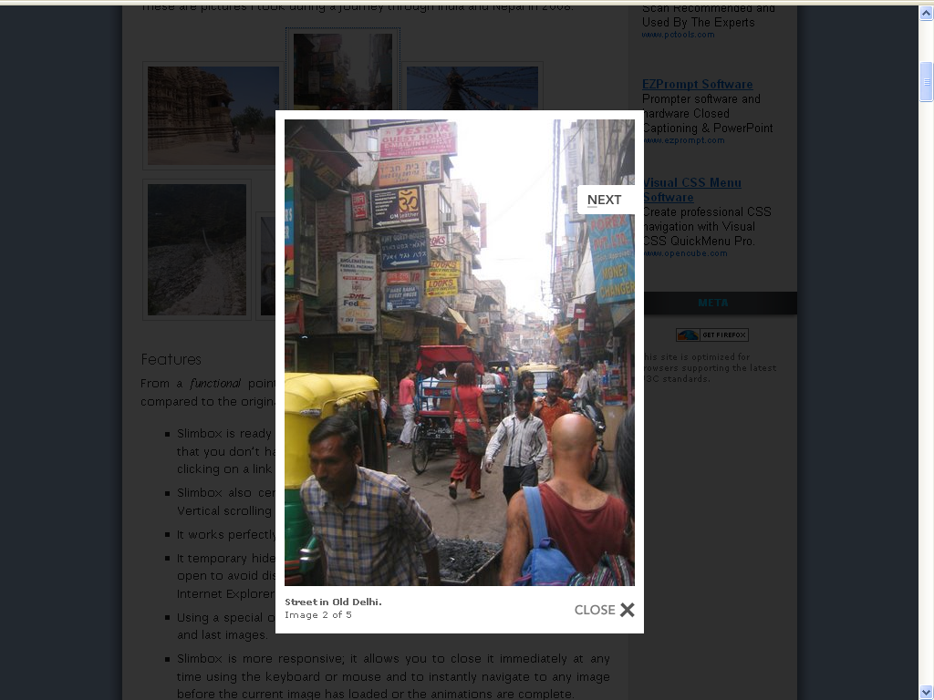 | http://www.digitalia.be/software/slimbox2 | MIT
JQuery | Ajax + IGU +Tools |  | 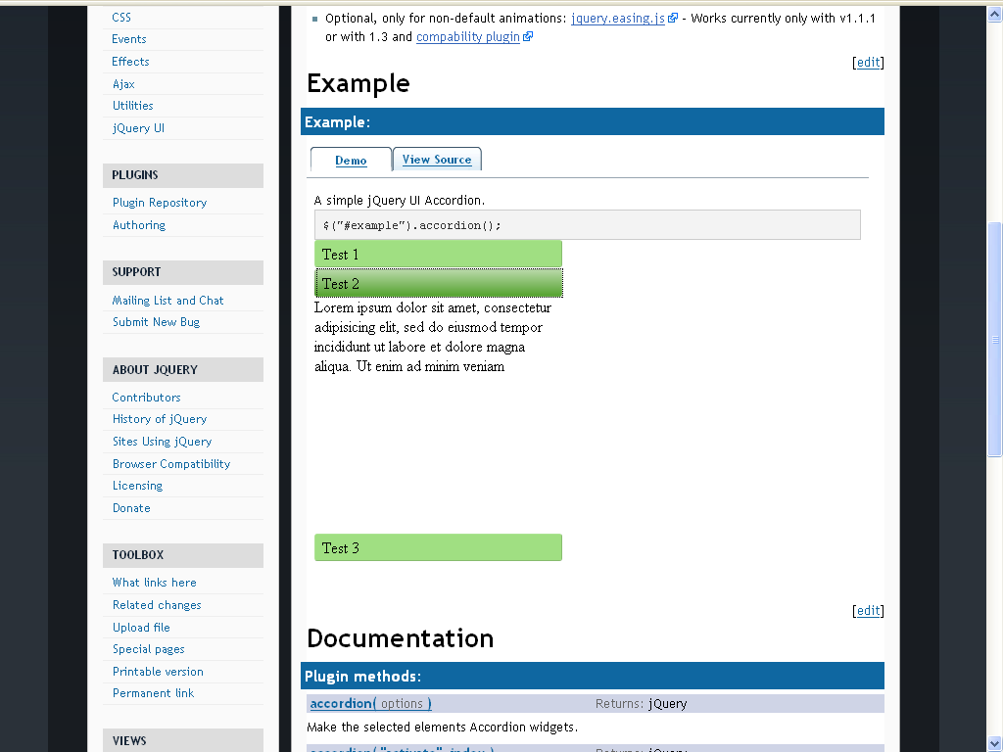 | http://jquery.com/ | MIT, GPL
ThickBox |  | JQuery | 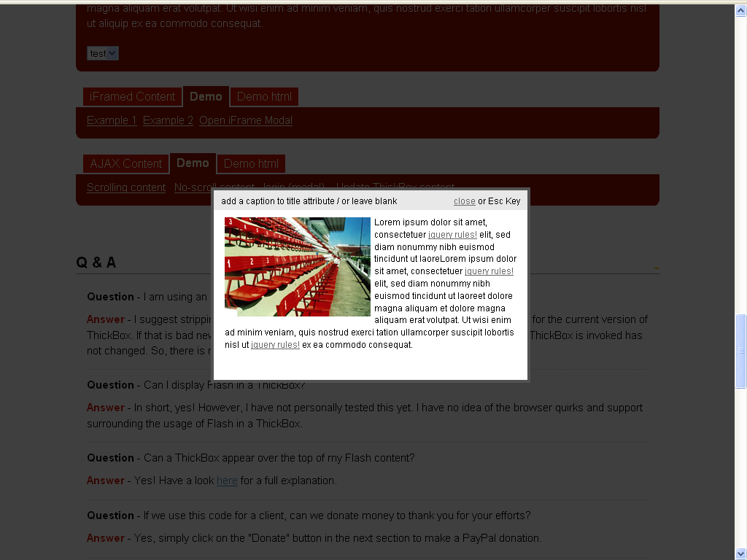 | http://jquery.com/demo/thickbox/ | MIT, GPL
LightBox | Photo viewer |  | 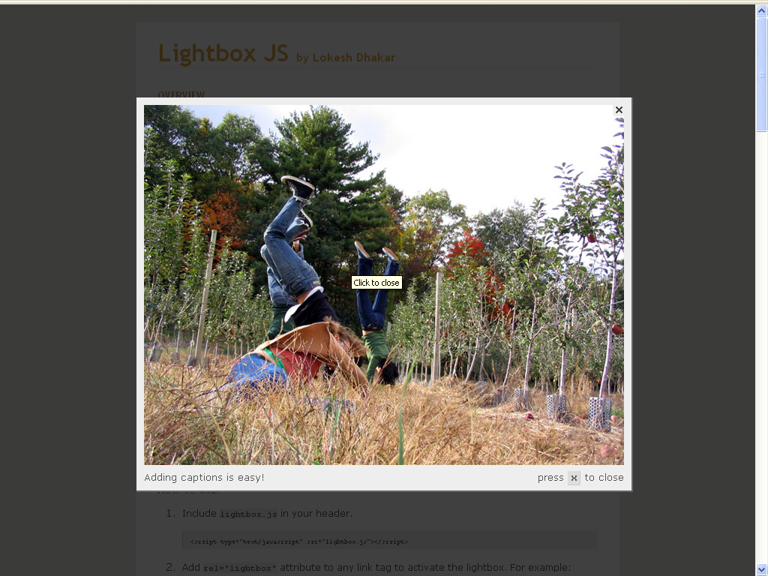 | http://www.huddletogether.com/projects/lightbox/ | Creative Commons Attribution 2.5 License
LightBox 2 | Photo viewer | Prototype, script.aculo.us | 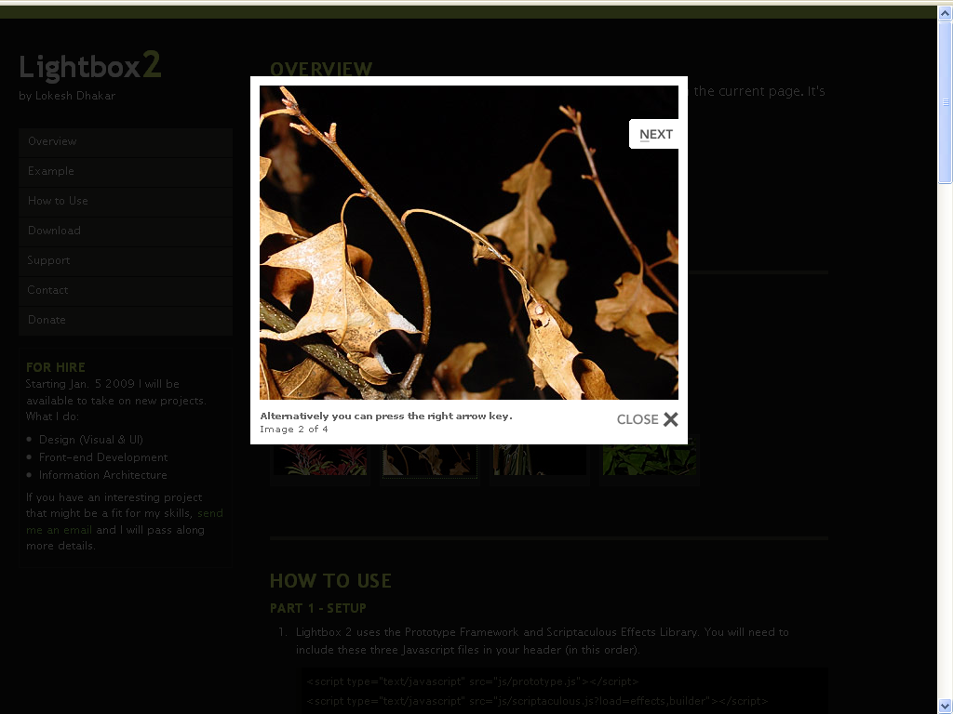 | http://www.huddletogether.com/projects/lightbox2/ | Creative Commons Attribution 2.5 License
Lytebox | photo/html/forms viewer + slideshow |  | 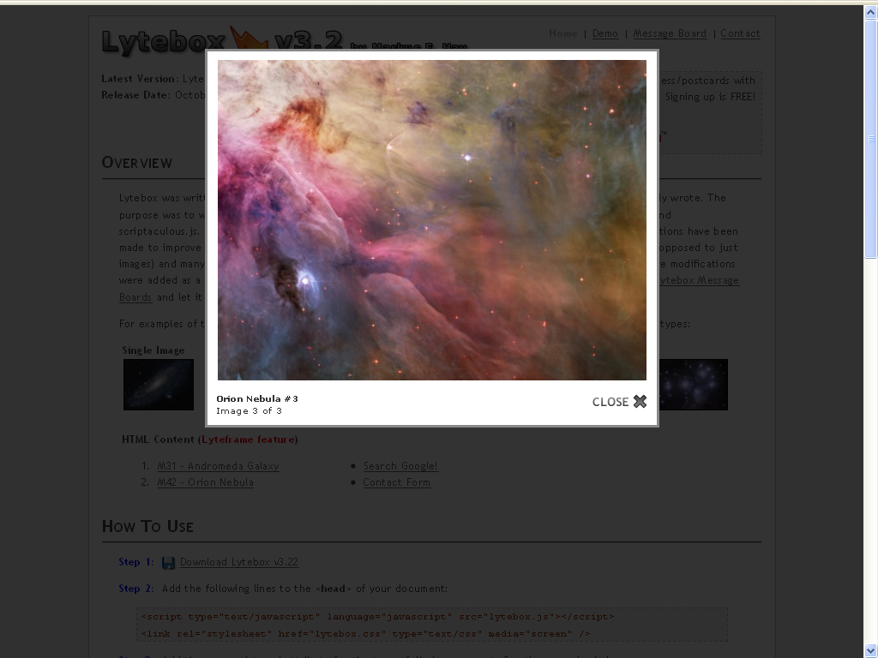 | http://www.dolem.com/lytebox/ | Creative Commons Attribution 3.0 License
Lightbox Gone Wild | Modal windows (foto+html+forms) | prototype | 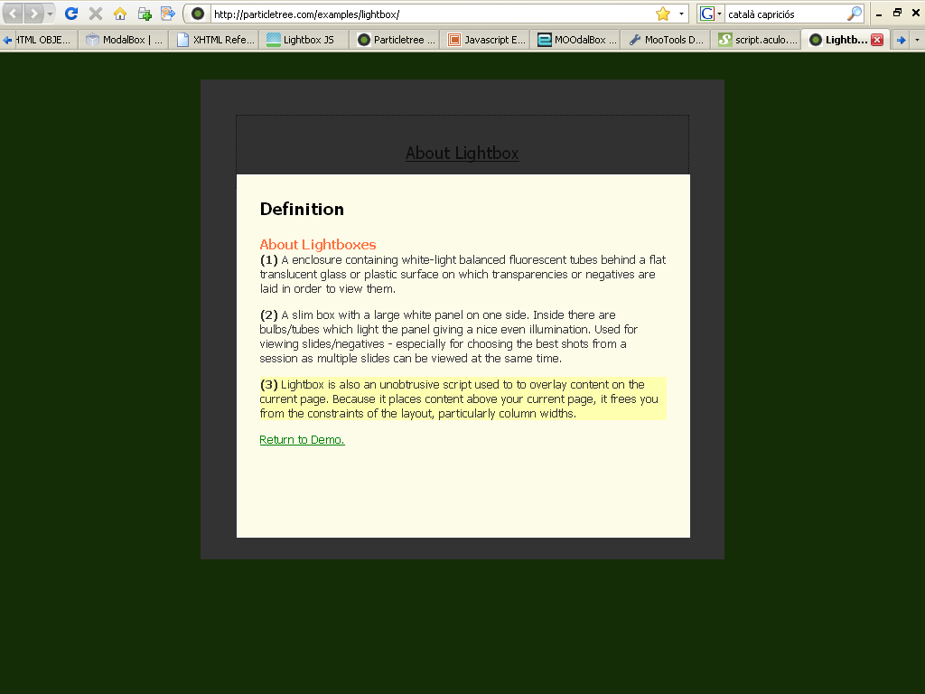 | http://particletree.com/features/lightbox-gone-wild/ | CreativeCommons Attribution license
Videobox | flashVideo viewer box | Mootools, swfobject | 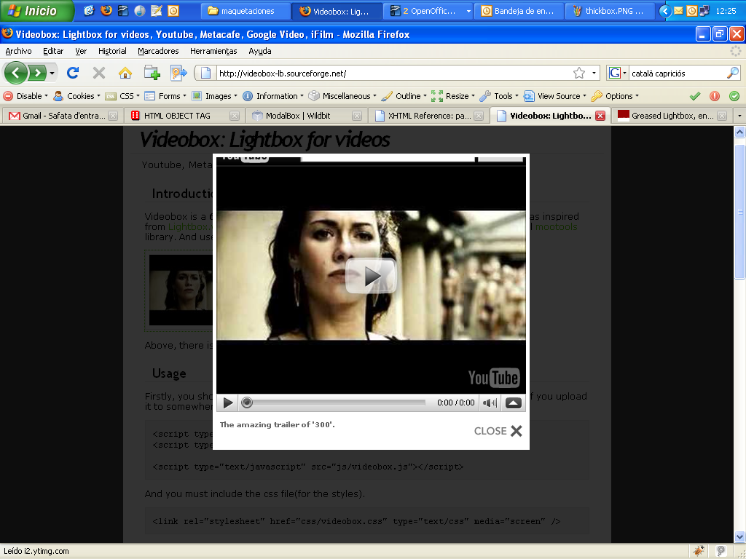 | http://videobox-lb.sourceforge.net/ | ¿?
DOM Pop-ups | Llibreria de pop-ups i menus | prototype | 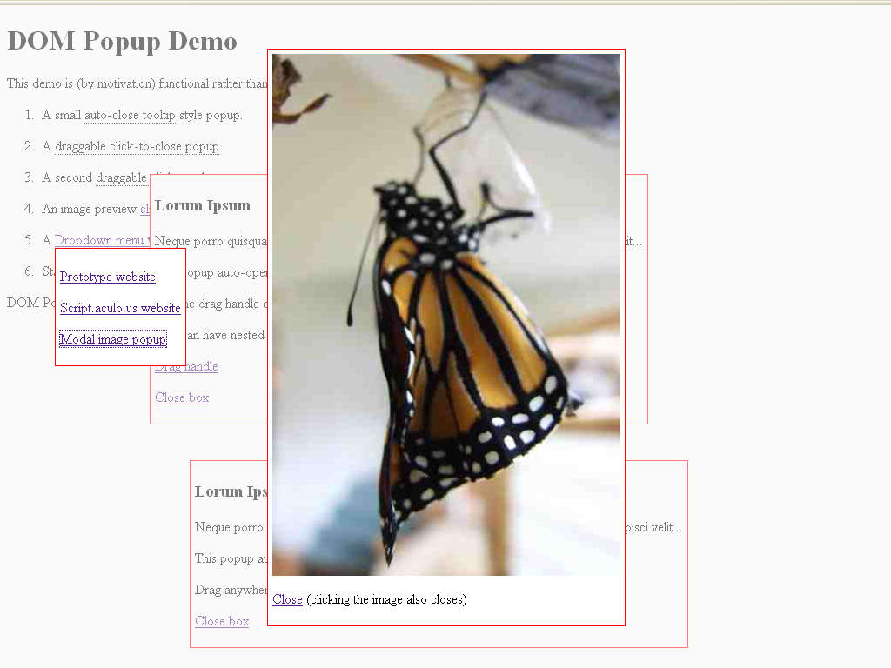 | http://www.methods.co.nz/popup/popup.html | Gpl like
ExtGWT i ExtJS | Widget toolkit, Ajax toolkit | prototype | 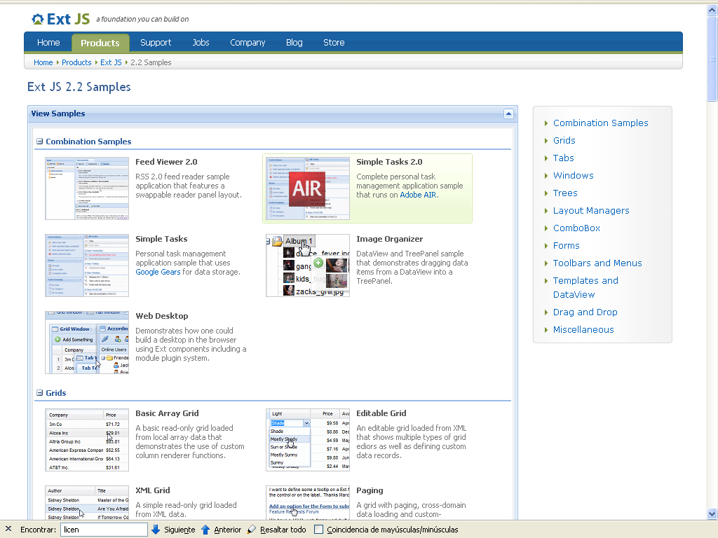 | http://extjs.com/ | GPL v3
Midori JS | Ajax toolkit (popups, drag&drop, special fx, etc..) |  | 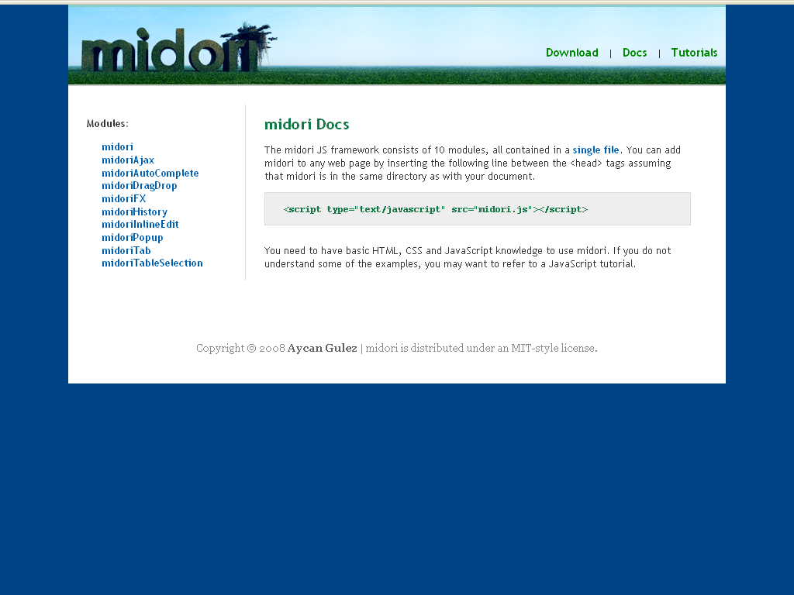 | http://www.midorijs.com/ | Gpl like
Modalbox | Modal box pop-ups | Script.acolo.us, prototype | 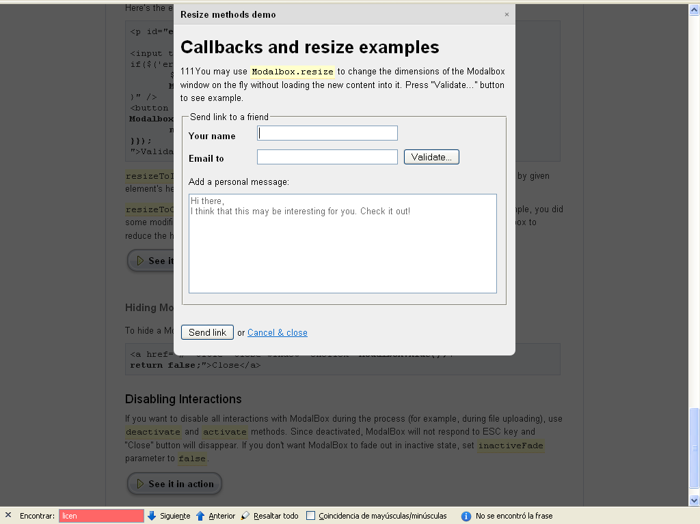 | http://www.wildbit.com/labs/modalbox/

Estic revisant unes altres llibreries per a interfícies d'usuari que imiten widgets d'escriptori. No m'ha donat temps a completar sa taula. ;-)
Exemples (mirar demo):
- http://rialto.improve-technologies.com/wiki/
- http://openrico.org/
- http://extjs.com/
- http://dojotoolkit.org/
- http://www.mochikit.com/demos.html (prou interesant)

